**Project Report On**

**“Web Application For e-Buy Tech”**

Submitted for 3rd semester project fulfillment towards the degree of

MASTER IN COMPUTER APPLICATIONS (MCA)

**Submitted To**



**Shree Swaminarayan Institute of Technology**

***(Affiliated to Gujarat Technological University)***

**December 2023**

**Submitted By :**

**Name Enrollment No**

Jaimin Koladiya 225330694028

Jaykrut Kotadiya 225330694029

Meet Nakrani 225330694038**Shree Swaminarayan Institute of Technology**



Gandhinagar-Ahmedabad Airport Highway, Bhat, Gandhinagar

Ph.: (079) 23969410

URL: [www.ssit.co.in](http://www.ssit.co.in)

**CERTIFICATE**

This is to certify that the SEMESTER III PROJECT (639404) titled

**“Web Application For e-Buy Tech“** developed by the following student(s)of M.C.A.Semester– III , named

1. Jaimin Vipulbhai Koladiya Enrollment No. 225330694028
2. Jaykrut Babubhai Kotadiya Enrollment No. 225330694029
3. Meet Jayntibhai Nakrani Enrollment No. 225330694038

have satisfactorily completed their project work as per the curriculum of Gujarat Technological University for the year 2023.

This is the original work and carried out under our guidance and supervision. We further certify that to the best of our knowledge and belief the matter presented in this project report is bonafied.

Date:

**External Evaluator Project Guide Director**

**Acknowledgement**

We extended our sincere thanks to our college **Shree Swaminarayan Institute Of Technology(SSIT)**,our respected HOD **Prof.Deena Pujara**, our respected faculties for giving us a golden opportunity to work on the project of “**WebApplication For e_Buy Tech”** website providing us their precious time, deep and valuable knowledge to make a project–a success.

We extend our warm thanks to our project guide for his guidance and constant encouragement throughout the semester for providing their valuable time, advice for various problems whenever we needed for deciding the objectives for our reports.

We express our thanks to our college library for providing us the required books necessary for our reference and computer lab staff for providing us necessary resources, permission to work on projects by staying late in labs and for providing help.

Finally, We would like to offer special thanks to **“Shree Swaminarayan Institute Of Technology(SSIT)”** for helping us a build a career and laying down a platform, which will help to build a career in the software Industry.

Yours Sincerely,

Mr. Jaimin Koladiya

Mr. Jaykrut Kotadiya

Mr. Meet Nakrani

|  |  |  |
| --- | --- | --- |
| **INDEX** | | |
| **No.** | **Contents** | **Page No.** |
| 1 | Project Profile | 1 |
| 3 | Work distribution among group members | 3 |
| 4 | Goals and Objectives | 4 |
| 5 | Problem Area & Project definition | 5 |
| 6 | System Analysis and Feasibility Study | 7 |
| 7 | Module Hierarchy: |  |
| 8 | Diagrams |  |
|  | 8.1 Use-Case Diagram | 19 |
|  | 8.2 Class Diagram | 21 |
|  | 8.3 Activity Diagram | 22 |
|  | 8.4 Sequence Diagram | 23 |
| 9 | Software Design |  |
|  | 9.1 Data Dictionary | 33 |
| 10 | GUI Design |  |
|  | 10.1 Screen Layouts | 38 |
| 12 | About the Tool and Technologies |  |
|  | 12.1 Tools | 54 |
|  | 12.2 Technologies | 54 |
| 14 | Bibliography | 55 |

**Project Profile**

|  |  |
| --- | --- |
| **Project Title** | Web application for e-Buy Tech |
| **Front End** | React Js |
| **Back End** | Laravel 8 |
| **Database** | MySQL |
| **Project Team Size** | 3 |
| **Submitted By** | 1. Koladiya Jaimin 2. Kotadiya Jaykrut 3. Nakrani Meet |

**Work distribution among group members**

Let’s me to clarify that there are three member in our group jaimin , jaykrut and meet. we work together in this project.

There is no work distribution among us. We have work on the all the modules.

**Goals and Objectives**

* + Admin can manage order efficiently.
  + Admin can manage product easily.
  + Customer can buy product easily.

.

**Problem Area**

* + Customer need to wait for product.
  + Admin have more responsibility.

**Project Definition**

**Project Name:** Web application for e-Buy Tech

**Project Description**:

e-Buy Tech is an innovative e-commerce web application designed to provide users with a seamless and secure platform for purchasing a variety of tech products, including mobile phones, chargers, laptops, earbuds, and more. The application aims to streamline the online shopping experience for tech enthusiasts, offering a diverse range of products from various brands.

**Analysis**

**Input :-**

The major inputs of the system are:

* + Admin can add new product.
  + Admin can add new product category.
  + Customer can place order.

**Output :-**

Various outputs are generated, once all the required inputs are provided to the application.

The major outputs of the system are:

* + Admin can see all the order
  + Customer can see all the product

**7.2 Project Modules**

1. Admin Module :-

* Manage Category
* Manage Product
* Manage Customer
* Manage Order
* Manage Payment
* Manage Feedback

2. Customer Module :-

* View Category
* View Product
* View Profile
* Add to Cart
* Place Order
* Give Feedback

3.Visitor Module:-

* Registration
* View Product

**8.1 Use Case Diagrams**

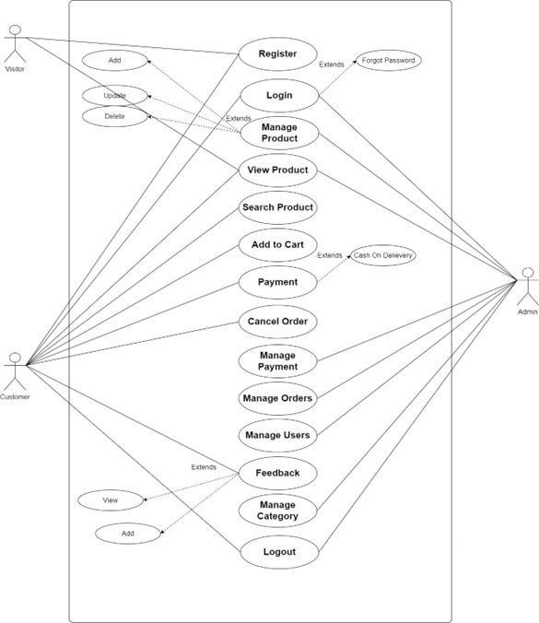

**8.2 Class Diagram**

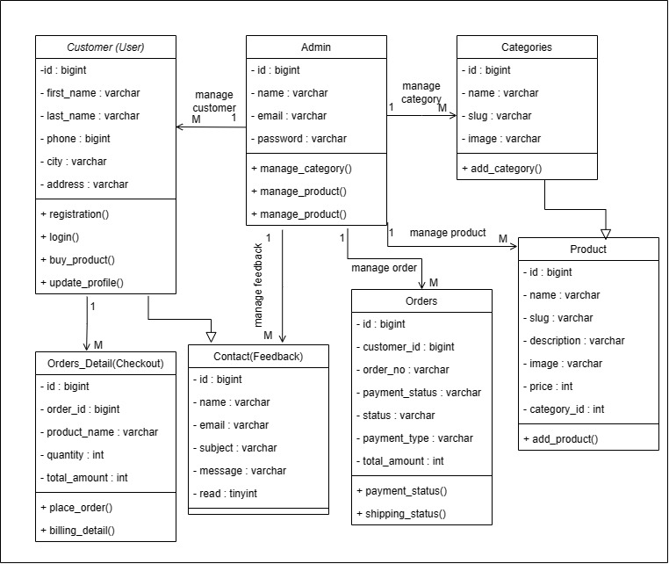

**8.3 Activity Diagram**

**User Activity Diagram**

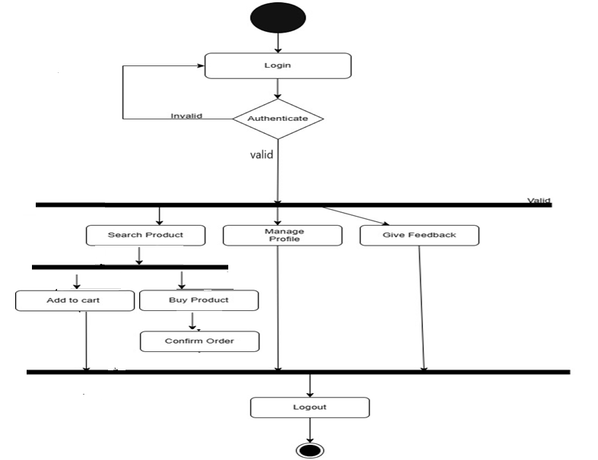

**Admin Activity Diagram**

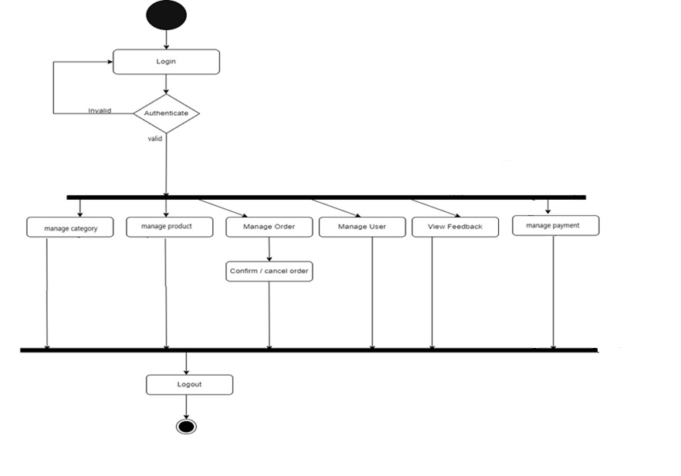

**8.4 Sequence Diagrams**

1. Registration

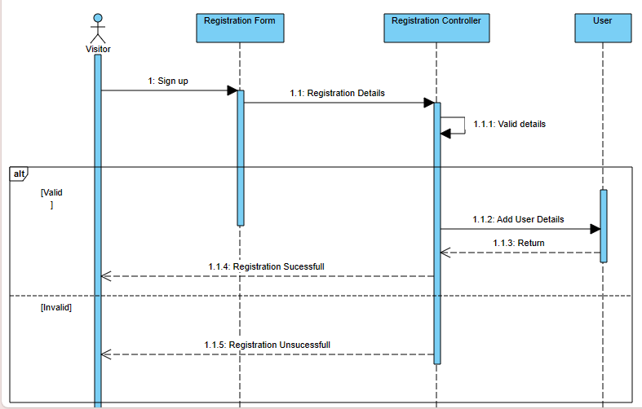

1. Login

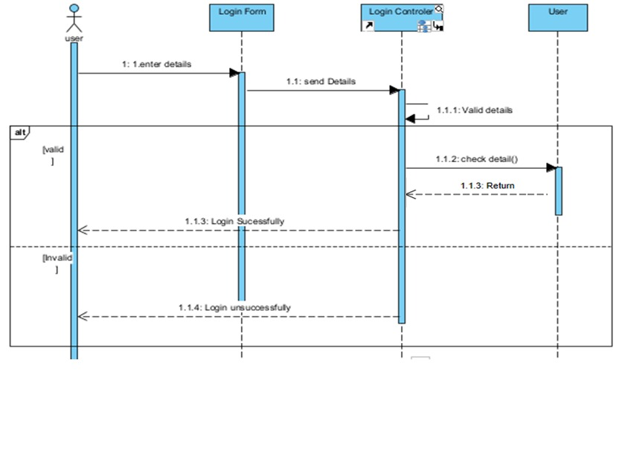

1. Add Category

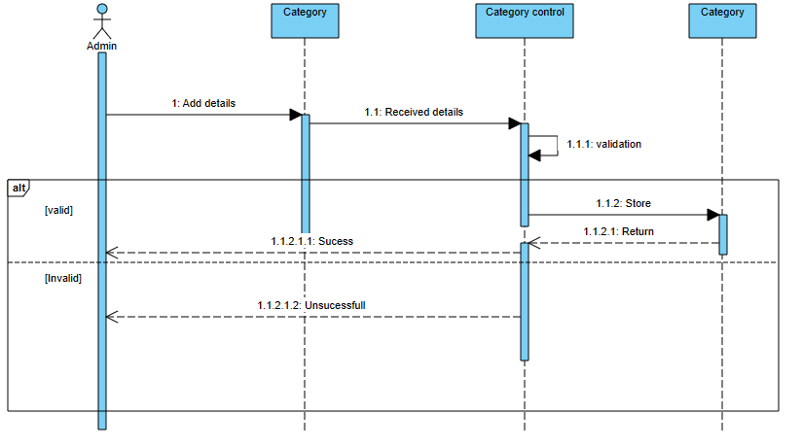

1. Search Product

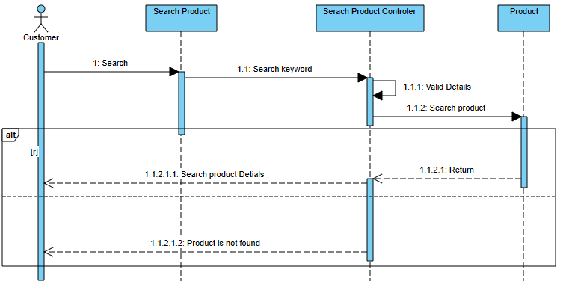

1. Add to Cart

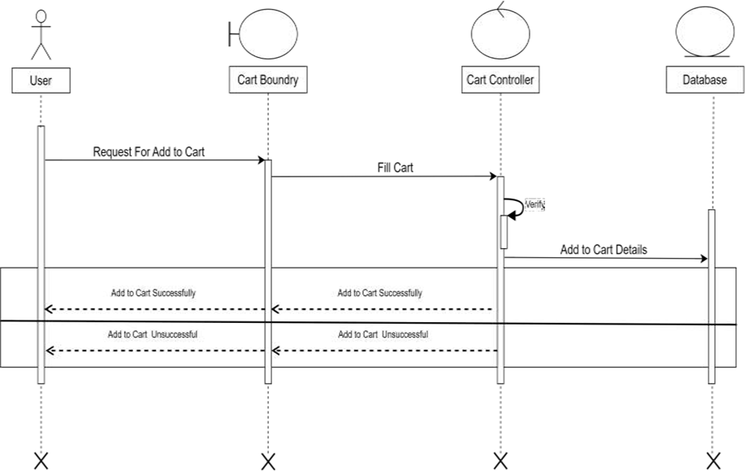

1. Place Order

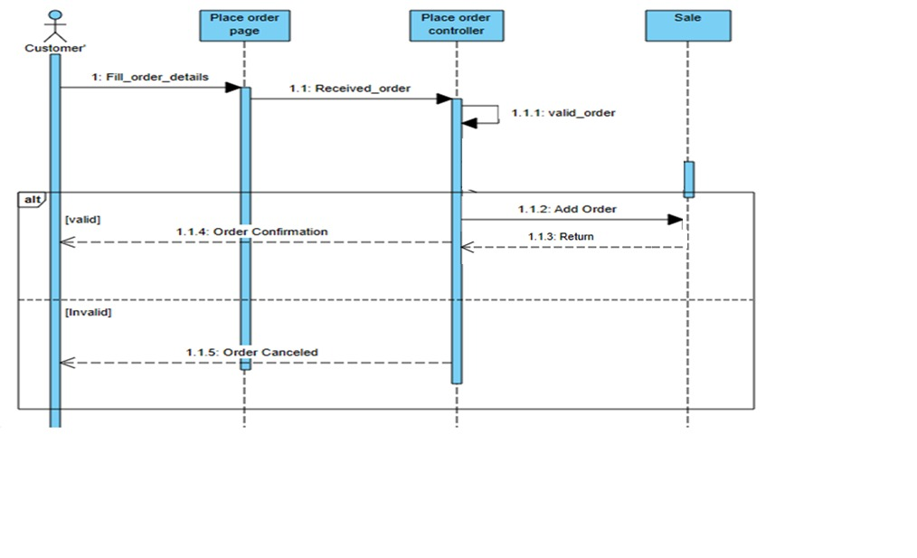

**9.1 Data Dictionary**

**Table Name:** User

**Description:** This table contains all the details of User.

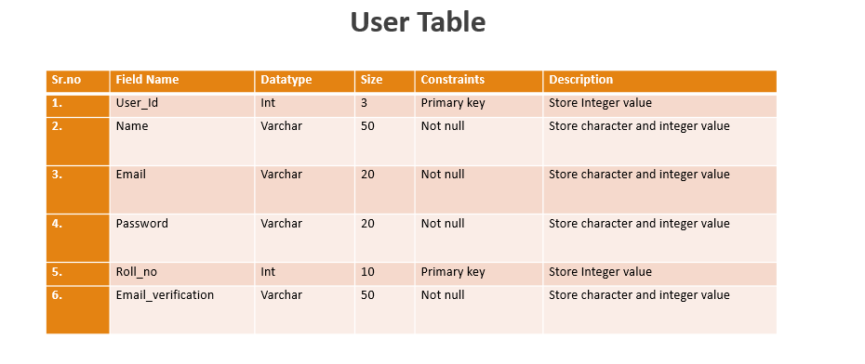

**Table Name:** Role

**Description:** This table contains all the details of Role.

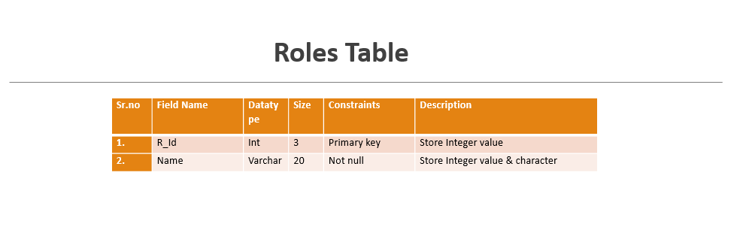

**Table Name:** Product

**Description:** This table contains all the details of Product

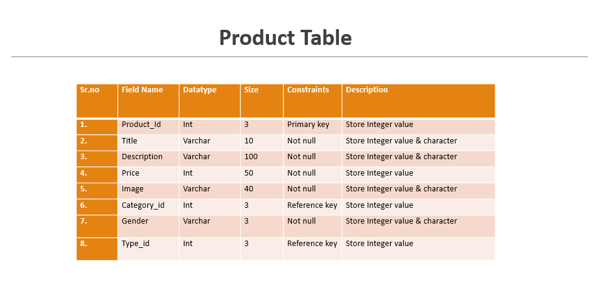

**Table Name:** Category

**Description:** This table contains all the details of Category.

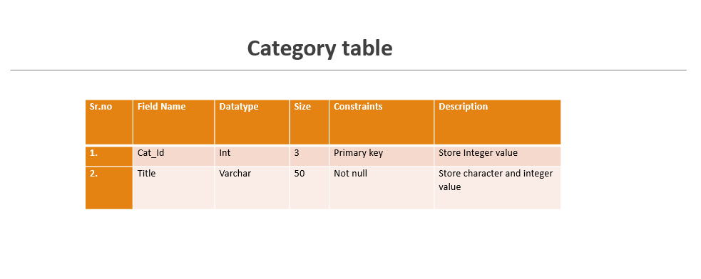

**Table Name:** Cart

**Description:** This table contains all the details of Cart.

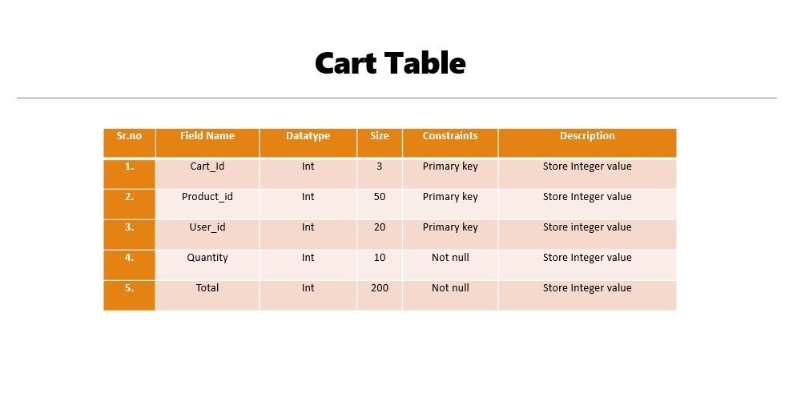

**Table Name:** Order

**Description:** This table contains all the details of Order.

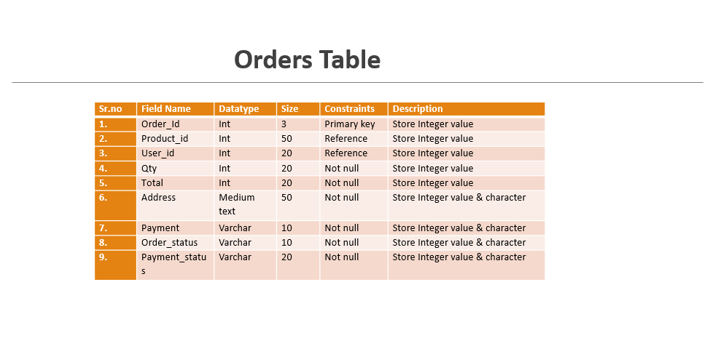

**Table Name:** Contact

**Description:** This table contains all the details of Contact.

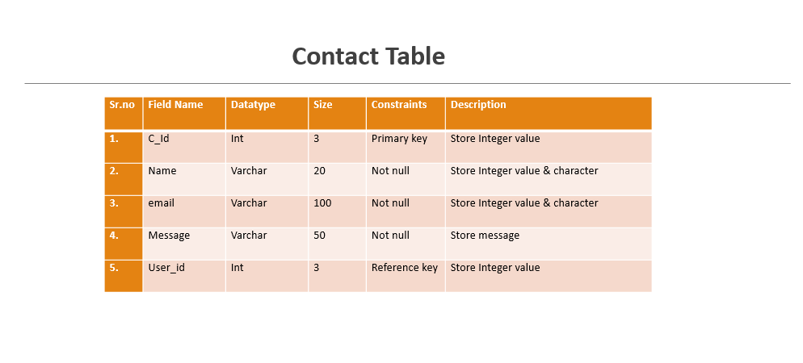 **Website Layout**

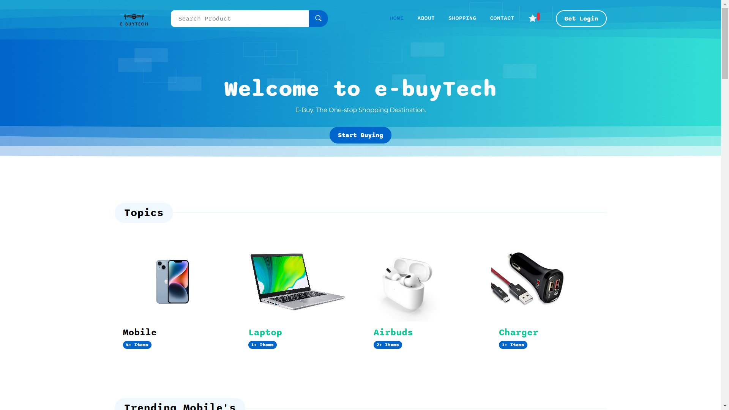

**Customer - Login/Register**

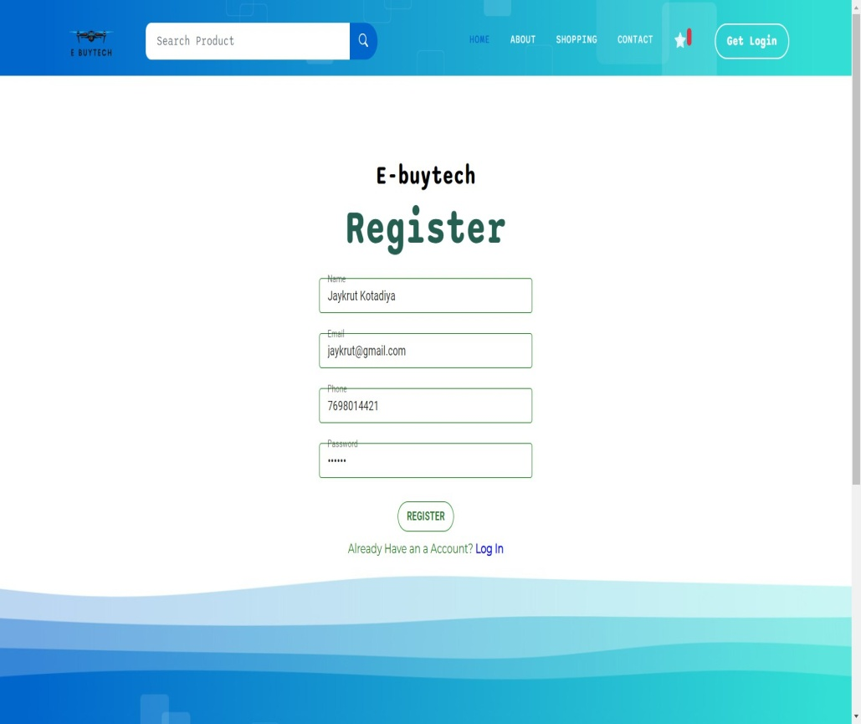

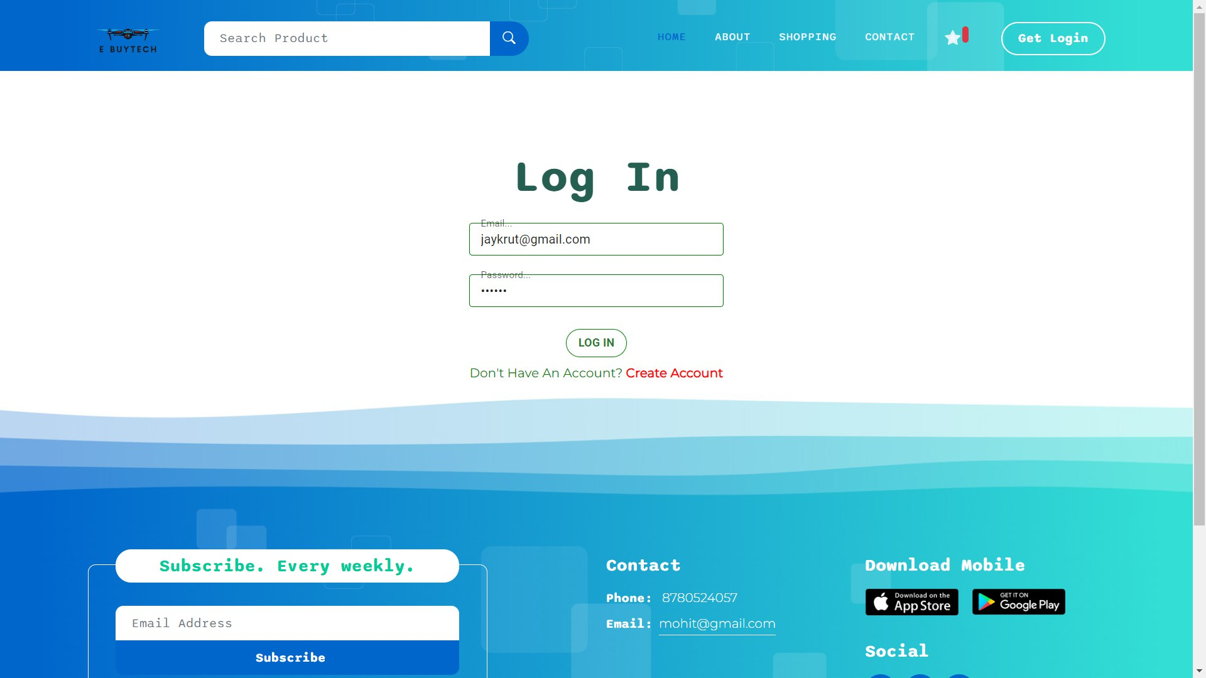

**Customer-About/Contact Us**

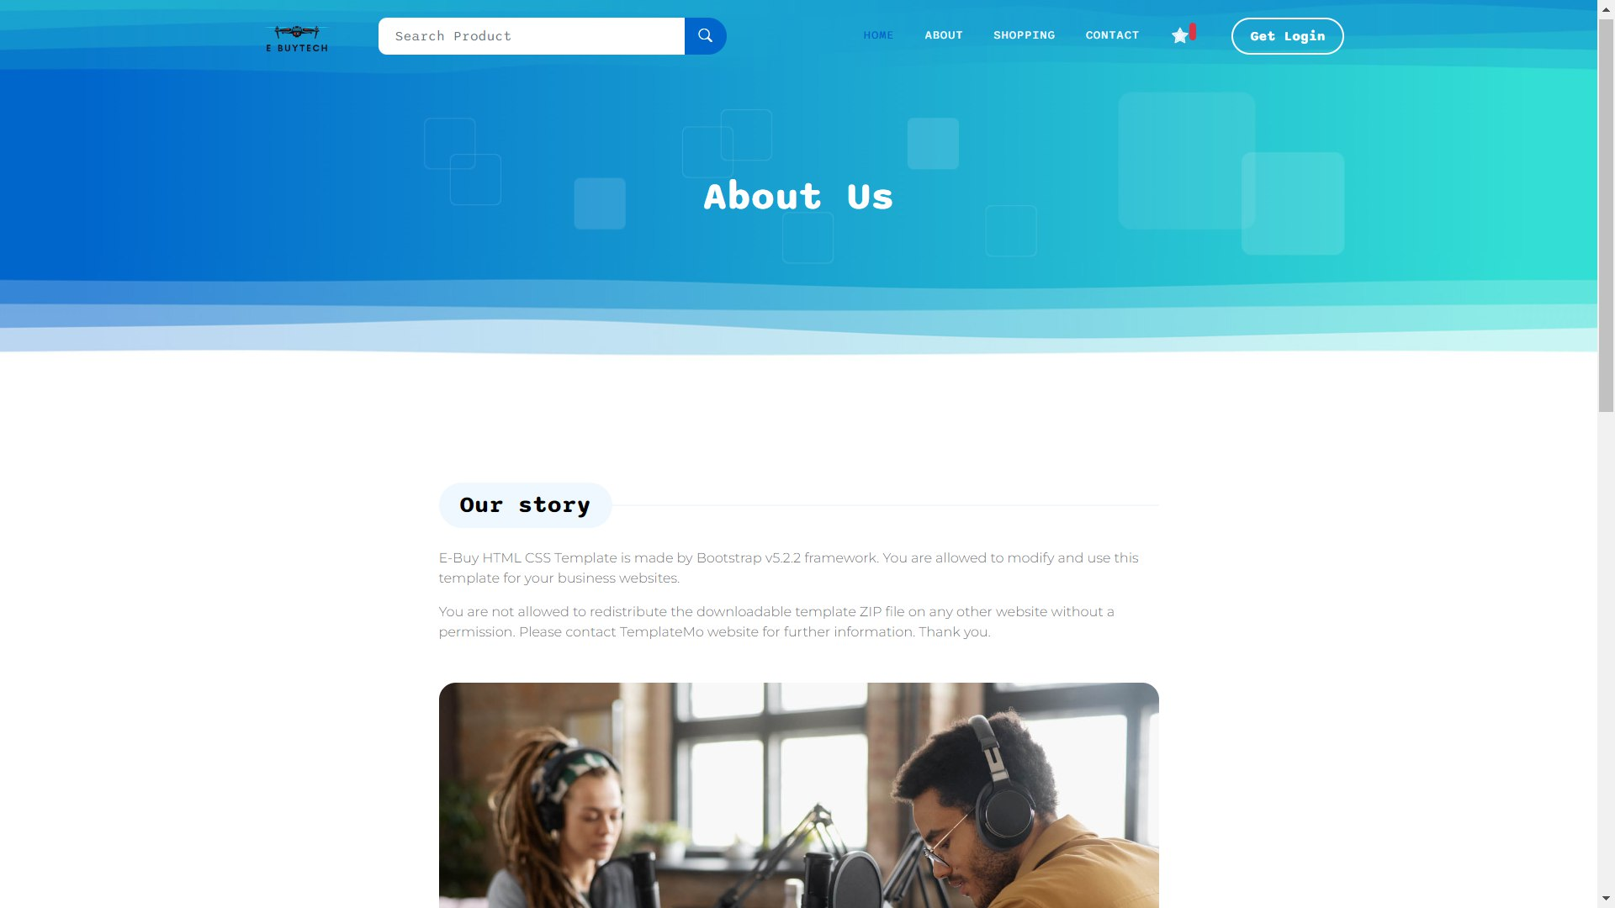

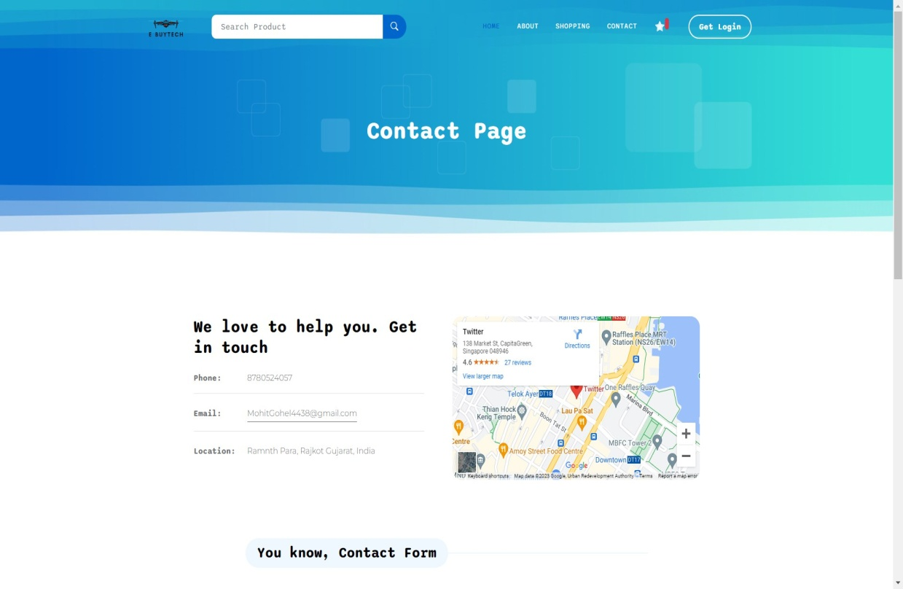

**Customer-Product Page**

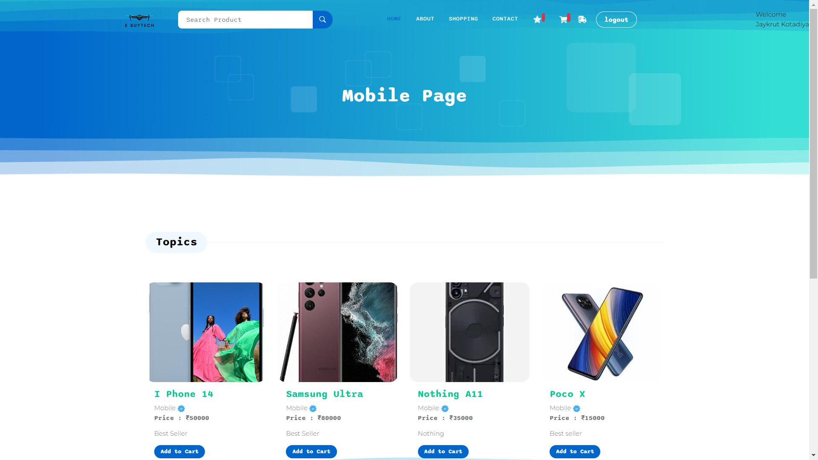

**Customer-Cart**

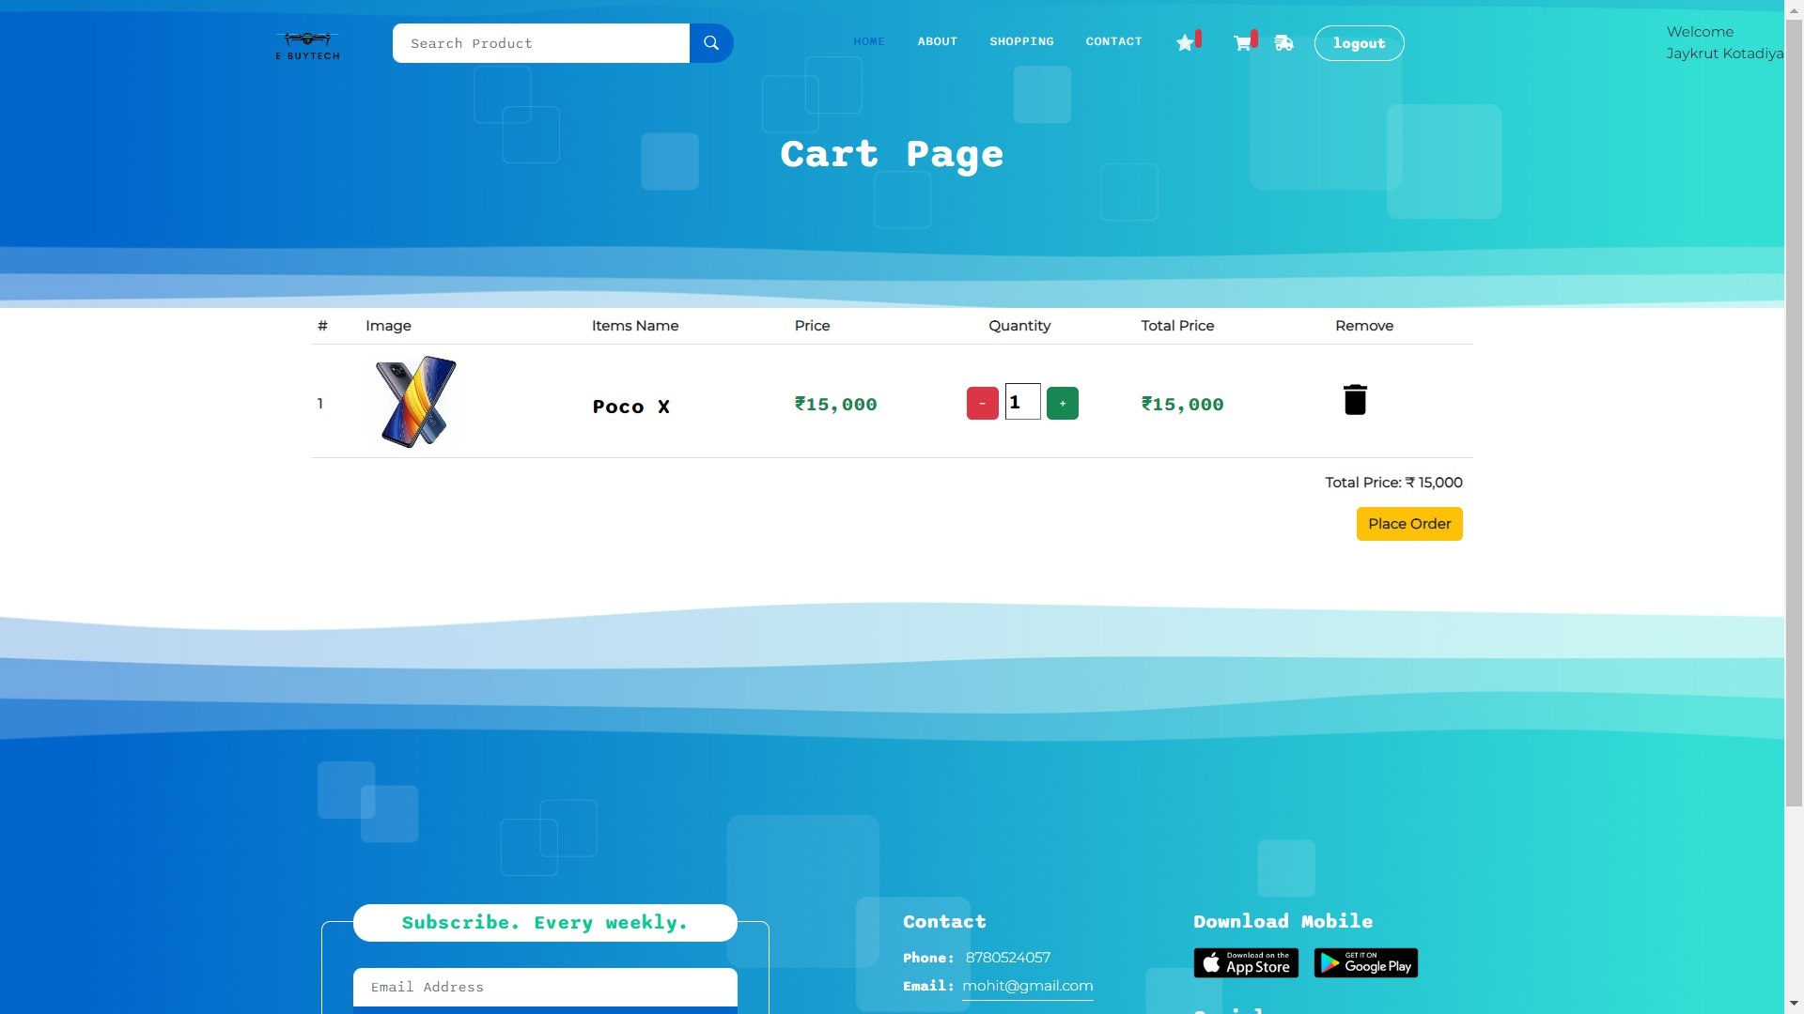

**Customer- Order Deatils**

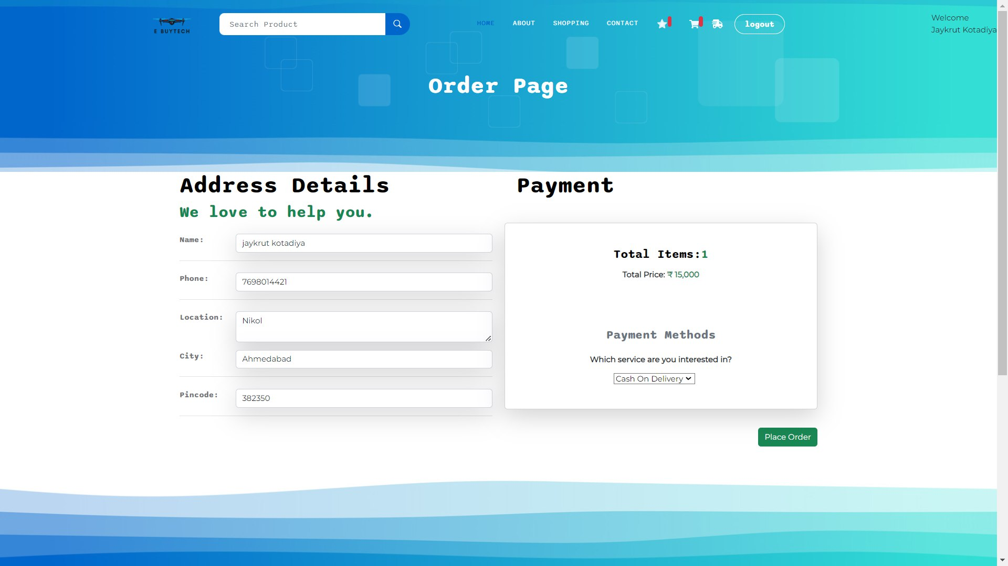

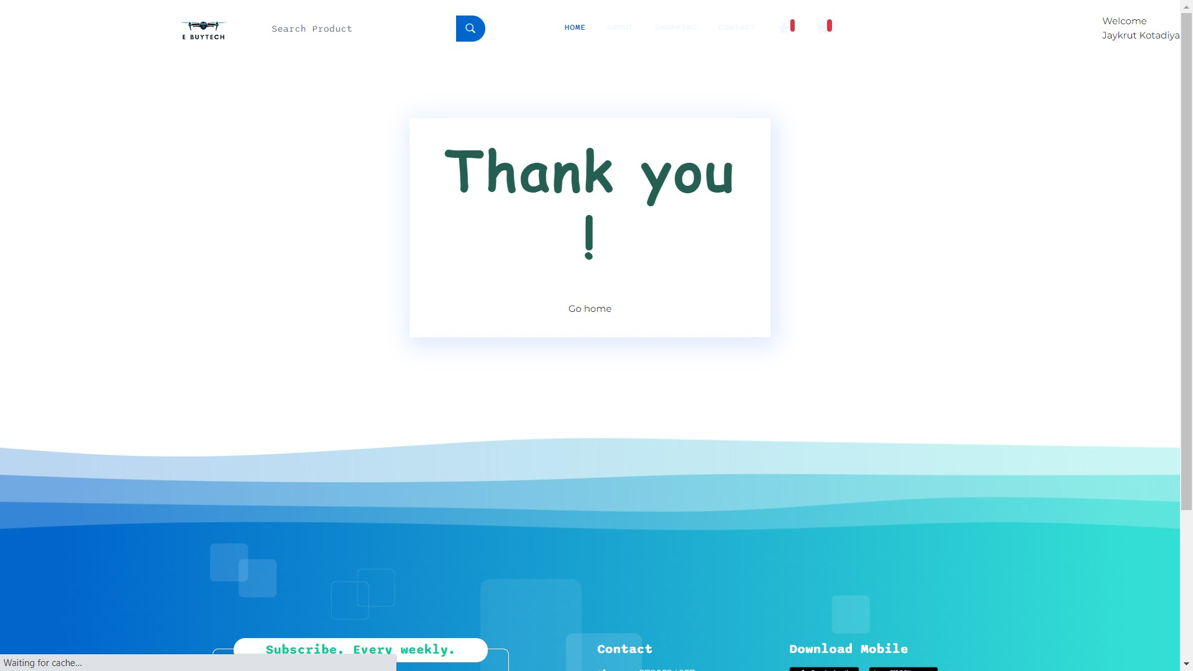

**Customer Order**

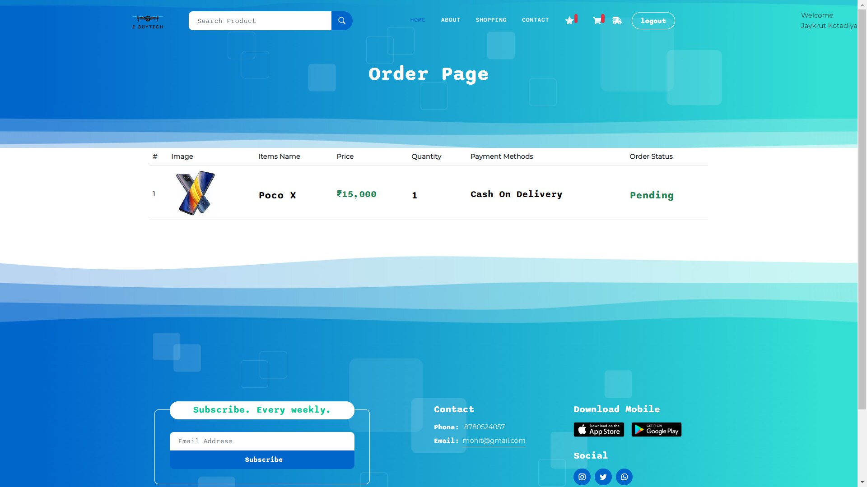

\

**Admin- Dashboard**

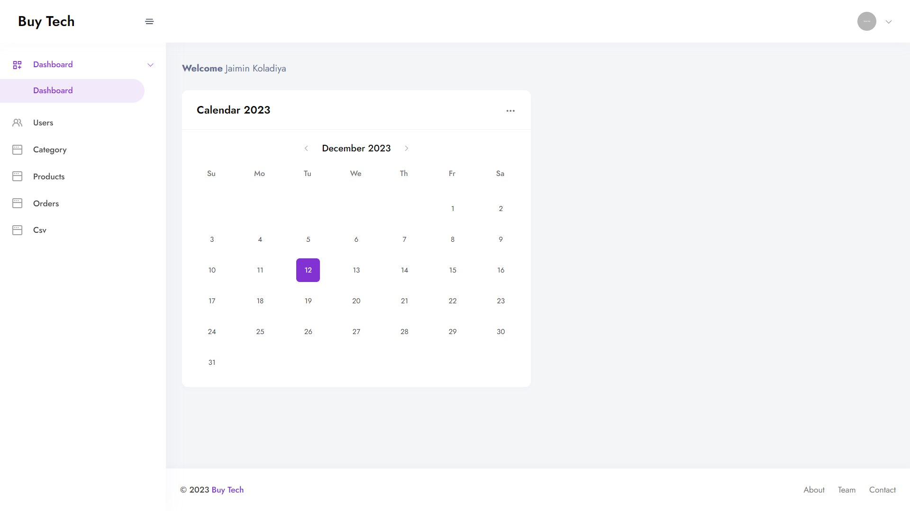

**Admin – All User**

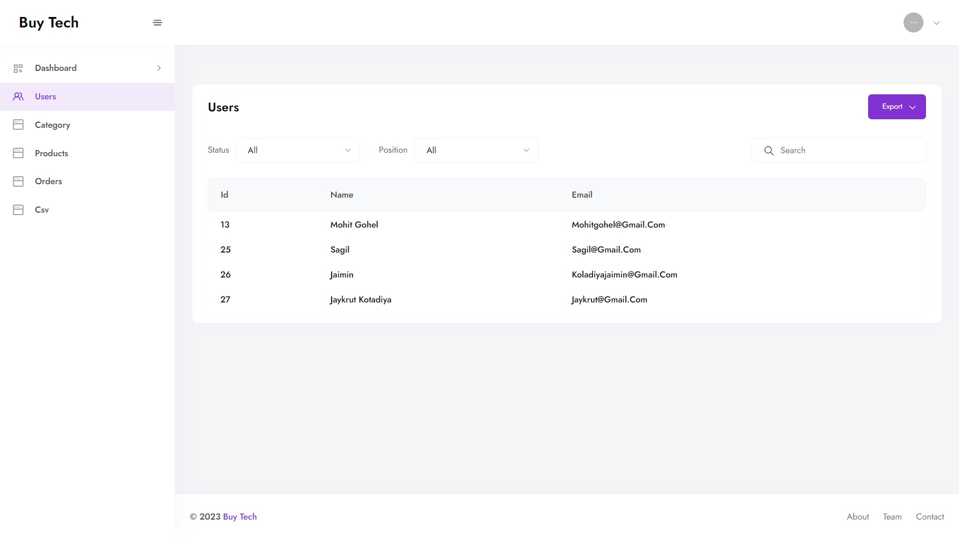

**Admin- Product Category**

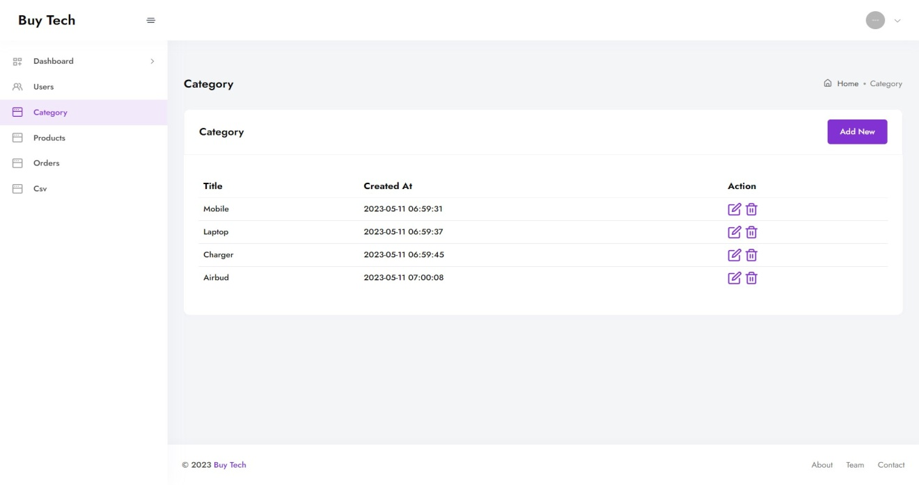

**Admin- All Product**

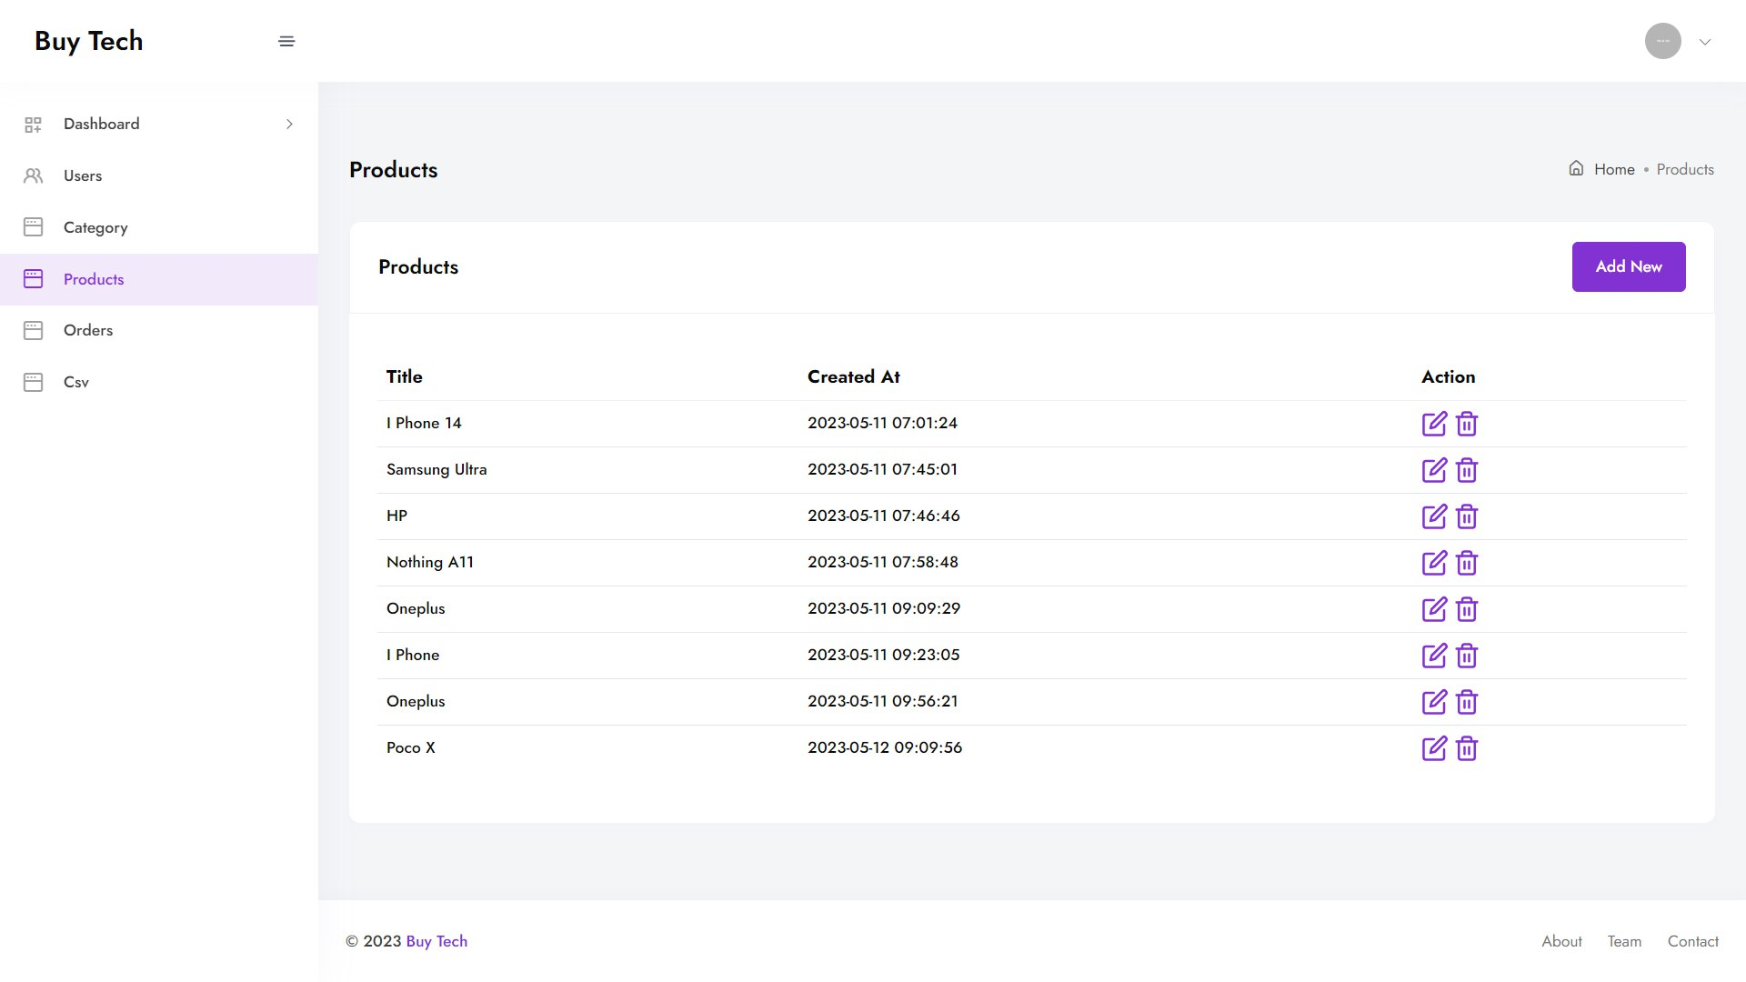

**Admin-All Order**

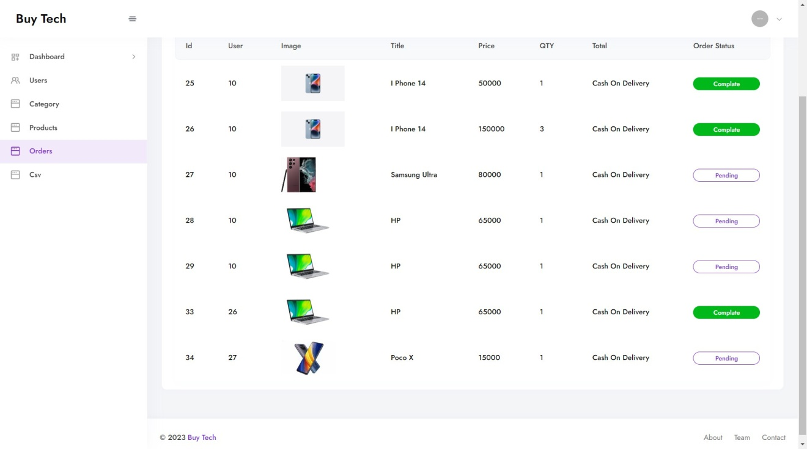

**13.1 Tools**

* Editor : Visual Studio Code
* UML Diagram Tool : Visual paradigm 8
* ER Diagram Tool : MYSQL Workbench 5

**13.2 Technologies**

* Front-End Languages : React Js
* Back-End Language : LARAVEL 8
* Database : MySQL 8
* Server : Apache 2

**15 Bibliography**

**Websites :-**

1. <https://laravel.com/>
2. <https://www.w3schools.com/>
3. <https://legacy.reactjs.org/docs/getting>